Fuad Nazlawi

South Sudan Humanitarian Crisis
South Sudan is one of the poorest countries in the world. Much of the nation is in the grip of a humanitarian crisis that had been fueled by decades of war, chronic underdevelopment, and natural disasters such as draughts and famines. Because of these factors, more than 9,000 people are losing access to food every day (Care.org, 2020). Moreover, the cumulative effects of protracted conflict, violence, and drought has rendered over seven million people - about two-thirds of the nation’s population – dependent on humanitarian assistance and protection (Care.org, 2020). Over the years, the humanitarian crisis in South Sudan has taken a global perspective, with millions of refugees moving to foreign countries to escape violence and hunger. As a result, social services in the host nations have become increasingly strained.
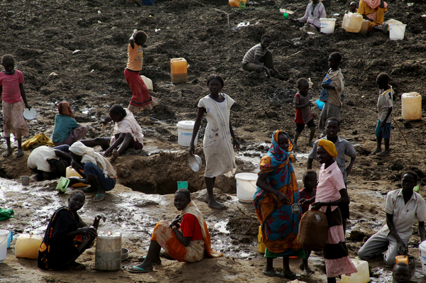
The international community has made concerted efforts to assist in peace funding and humanitarian efforts in South Sudan. According to Liaga (2017), the most prominent external actor in the resolution of South Sudan crisis has been the Intergovernmental Authority on Development (IGAD). This organization is constituted under the auspices of the African Union. IGAD has been the principal peacemaker since the outbreak of South Sudanese war in 2013. However, most of the peace efforts in the country have been fruitless, with the warring sides failing to agree on critical terms such as power sharing. As a result, millions of people, including men and children, continue to live in sordid refugee camps, while the country continues to experience economic destruction due to limited production activities. Image 1 above is an illustration of the hardships that many South Sudanese refugees experience in refugee camps. In the photo, women and children are seen searching for water in a dry river bed. Lack of access to clean water has resulted in disease outbreaks on refugee camps, leading to thousands of deaths. The most urgent need for citizens in South Sudan is the quick resolution of the political conflict. This will allow people to return to their homes and participate in nation-building activities. IN the meantime, refugees need urgent care and protection, as combatants have a history of attacking unarmed citizens.

References
Biron, C. L. (2020). Refugees in South Sudan Facing "Full-blown Humanitarian Crisis". Retrieved February 27, 2020, from https://www.ipsnews.net/2012/06/refugees-in-south-sudan-facing-full-blown-humanitarian-crisis/
Care.org. (2020, January 29). Humanitarian Crisis in South Sudan. Retrieved February 27, 2020, from https://www.care.org/emergencies/south-sudan-humanitarian-crisis
Liaga, E. (2017). International Community in South Sudan: What Does It Mean For Local Peace. Retrieved February 27, 2020, from https://africaupclose.wilsoncenter.org/international-community-in-south-sudan-what-does-it-mean-for-local-peace/

